# Trivia plan and things to do

1. Introduction - welcome and sponsor - still open the survey
2. Slides with the questions on it (5 rounds of 6 questions?)
3. Questions and answers written on a word document
4. Create pieces of paper with number 1 to 10 to give randomly when they arrive and that will create random teams
5. Consider 4 pieces of paper per team - teams of 5-6? Depends on the number of people.
6. Teams have to choose a team name and number from 1 to six every piece of paper
7. After reading every round papers for that round are collected and corrected
8. Survey response rate is very low. Encourage the attendees to fill the survey if they haven’t already.

**Round 1 - R related history**

#### Name two people that invented the S programming language, the predecessor of R? John Chambers & Rick Becker

There were others present at the beginning of S development! 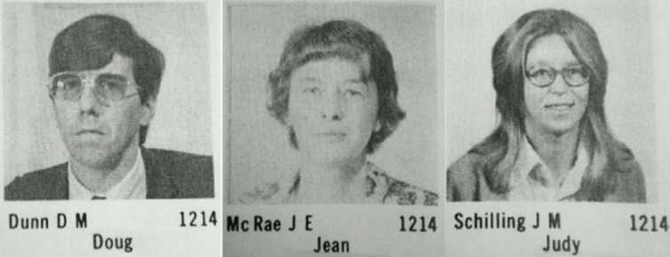

#### What does CRAN stands for? The Comprehensive R Archive Network

#### How many CRAN mirrors are there for Australia? 2 - CRAN mirrors are country-specific repositories to download R

#### Who is the author of Advanced R & R Packages books? Hadley Wickelm

#### Where is the next UseR (UseR! 2017) conference going to be held? Brussels, Belgium

**Round 2 - General R**

#### What is the most popular CRAN package for data visualisation based on grammar of graphics? ggplot

#### What is the expression that signals skipping the current iteration and going to the next iteration in a loop? next

#### What is the command set before generating random numbers that ensures reproducibility? set.seed()

#### Name at least one R package for Parallel programming/parallelization. parallel, snow

#### What is the the function that writes console output to a file? sink()

**Round 3 - Visualisation**

1. Which plotting functions have been used to produce the Christmas trees? polygon, plot, points, rect. You can find the code at https://gist.github.com/jtleek/4369771

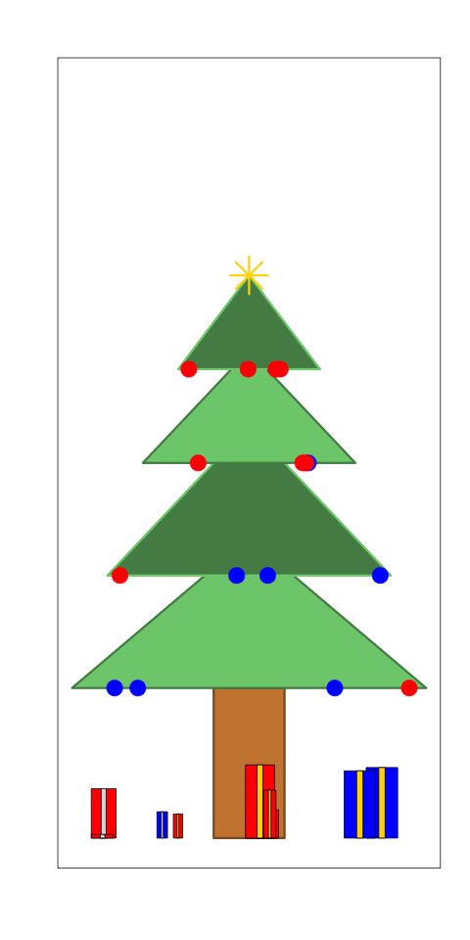

1. Which function made me?

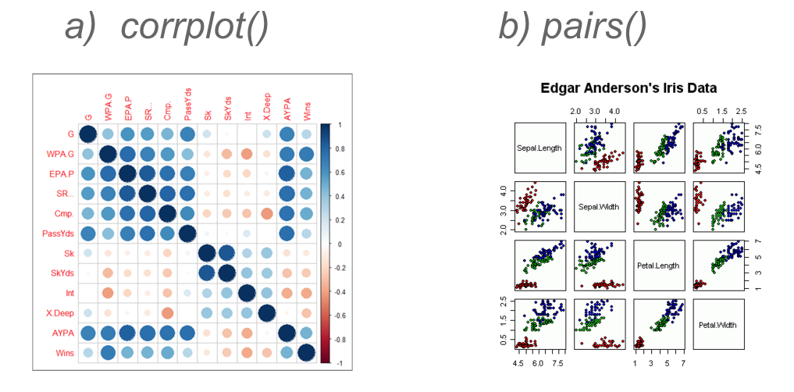

1. Which functions have been used to set plots on the same figure?

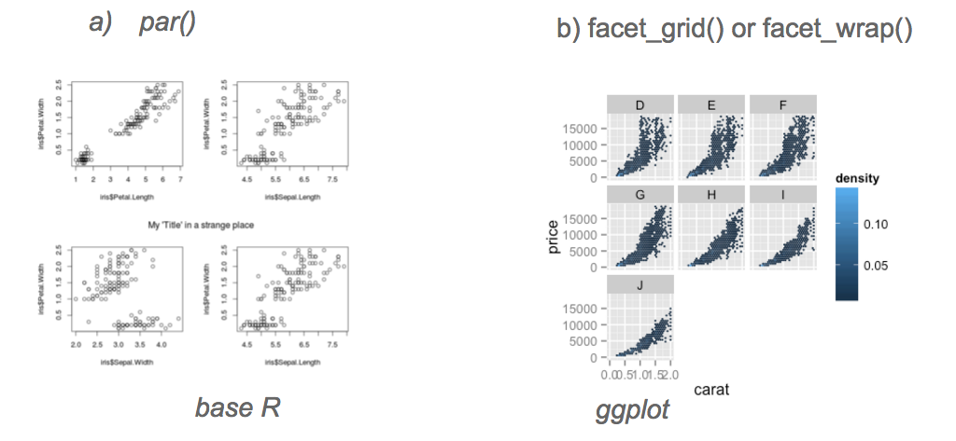

1. Which ggplot ‘geom’ am I ? geom_boxplot()
2. Which ggplot ‘geom’ am I ? geom_bar()

**Round 4 - R and other systems**

#### The Rstudio Service that facilitates interactive data analysis is: a) Rstudio Server b) Shiny c) RMarkdown

1. What is the R package that allows R and C++ flawless integration? Rcpp

#### State a file format for making dynamic documents with R - Rmarkdown

#### How can you install packages from CRAN and GitHub? install.packages() install_github()/devtools()

#### What is the function used to execute command-line/shell commands from within R? system()

**Round 4 - Functions**

1. The command to check if all rows in a matrix/data frame have non-NA values? - complete.cases(), is.na()
2. Which code is more efficient ( m is a matrix)?
   * 1. for (i in 1:ncol(m)) { sum(m[ ,i]) }
     2. apply(m, 2, sum)
     3. colSums(m) - because of vectorisation
3. Name a function that lists files in a directory based on a pattern or a suffix list.files(), dir()
4. which of the following commands return the indices of the matched patterns?
   1. grep(pattern, x) - returns index
   2. grep(pattern, x, value = TRUE) - returns the grepped value
   3. grep(pattern, x, invert = TRUE) - returns everything but the one with matches to the pattern specified

TEAM NAME

_______________________________

(Choose the team name you prefer and write it on the answer sheet)